**Experiment 3: Hybrid Rocket Motor**

**Aim:** To find regression rate of hybrid fuel

**Introduction**

A hybrid rocket is basically a combination of solid and liquid propellant rockets. Hybrid rocket contains fuel and oxidizer in different phases. Generally, the fuel is in a solid phase, while oxidizer is in gaseous or liquid phase, as shown in Fig. 1.

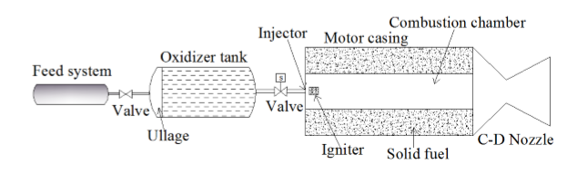

Figure 1: Hybrid Rocket Motor

In the 1950s, fuel in liquid phase and oxidizer in solid phase was also introduced for the hybrid rocket system. This type of hybrid system is called the reverse hybrid rocket and is not as practical as the classical hybrid system. This is due to the crystalline nature of the oxidizer, which makes it difﬁcult to fabricate a solid oxidizer grain. The most common solid fuels used in a hybrid rocket are polyethylene, plexiglas, hydroxy terminated poly-butadiene (HTPB) and rubber. Typical oxidizers used are liquid and gaseous oxygen, hydrogen peroxide, nitrogen tetroxide and nitrous oxide.

The hybrid rocket has many advantages over solid and liquid rocket engine. A solid rocket is known for its simplicity in construction but is unsafe in handling, manufacturing and transportation of the propellants, which increases the overall cost of the system. In a hybrid rocket, fuel and oxidizer are stored separately, which makes it safer to handle and manufacture the propellant. Throttling, start, stop and restart are easily possible in a hybrid rocket by controlling the oxidizer supply, but it is not possible in a solid rocket. The burn rate of solid rocket depends on the combustion chamber pressure. Thus, the presence of any blow holes in the propellant would increase the surface area of propellant and would increase the burn rate as well as combustion chamber pressure, which could be dangerous. In a hybrid rocket, combustion is primarily controlled by the oxidizer mass ﬂux (Gox) and is nearly independent of combustion chamber pressure. Hence, the presence of blow holes in the fuel is not a critical parameter. Hybrid rocket have a higher speciﬁc impulse than of a solid rocket.

Hybrid rocket has many advantages over liquid rocket engine too. In a liquid rocket engine, fuel and oxidizer are stored outside the combustion chamber, which are then injected into the combustion chamber with the help of the feed system. While in a hybrid rocket, the feed system is needed only for the injection of oxidizer, which reduces the complexity of the system by half. A cooling system is needed in a liquid rocket engine to prevent the metal casing from getting heated up. This is not needed in hybrid rocket as the fuel acts as an insulation layer preventing the heating up of the metal casing.

Apart from all the above advantages over solid and liquid rocket engines, it has certain disadvantages too. The regression rate of a hybrid rocket fuel is very low. Hence, in order to get the required thrust, fuel grain having a large burning surface area is needed. This requirement increases the complexities in manufacturing the fuel grain and reduces the volumetric loading. The O/F ratio is observed to change during combustion, which further changes the speciﬁc impulse with burn time. Thus maintaining a constant thrust is not easy even if one maintains a constant oxidizer ﬂow. The sliver loss is also higher in hybrid rockets as compared to solid rockets. The combustion efﬁciency is also lower as compared to the solid and liquid rocket engine.

**Experimental setup**

The experimental facility used for the current experiment is shown in Fig. 2. It consists

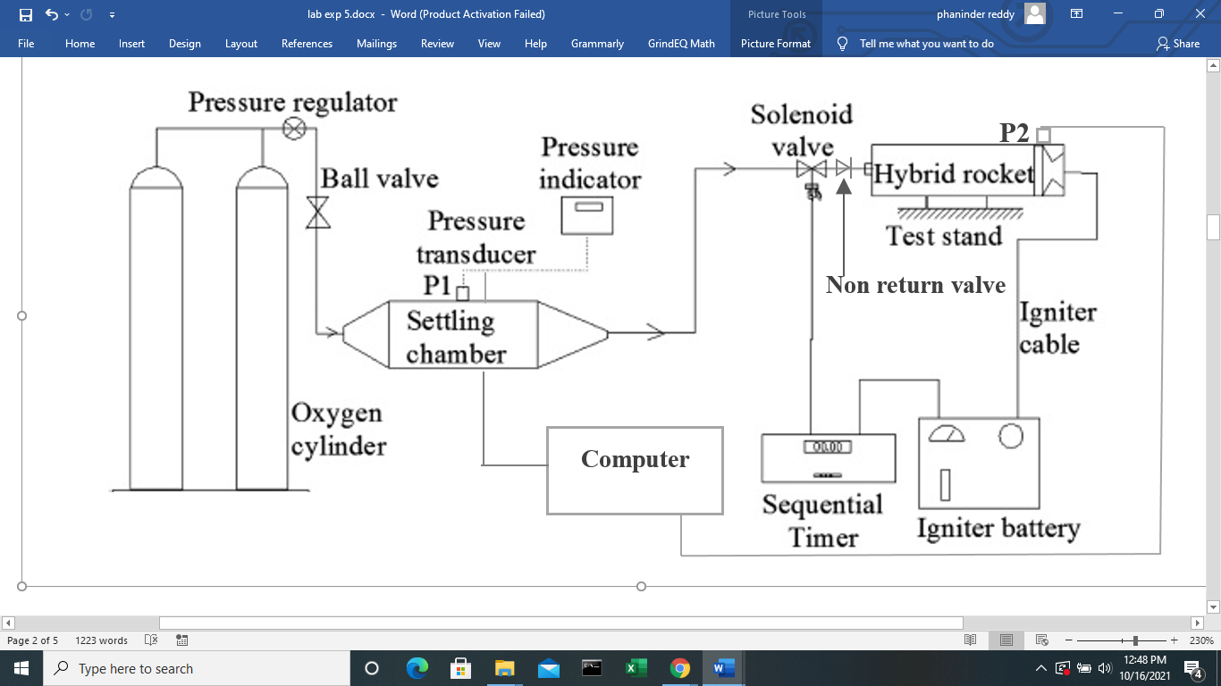 Figure 2: Schematic diagram of the experimental set up

of two to four (for high ﬂow rates), where constant mass ﬂow rate was obtained by allowing the oxidizer to ﬂow through a settling chamber as shown in Fig. 2. The pressure downstream of the pressure regulator was maintained constant. The outlet diameter of the settling chamber was chosen such that the ﬂow was choked and mass flow rate of oxygen was calculated. The settling chamber pressure was measured with the help of pressure transducer (P1). A sequential timer was used to control the functioning of the solenoid valve and the igniter battery. The sequential timer keeps the electrical circuit connected for a pre-determined time after which it was disconnected. Hence, it controls the time of the ignition process, as well as the time for which the solenoid valve is open. An igniter consists of a small amount of solid composite propellant (0.25 g) in which a nichrome wire is embedded. This combination along with a sufﬁcient length of the electrical wiring was then inserted into the rocket motor through the nozzle such that the solid propellant is located near the head end of the motor. An igniter battery supplied a voltage of 12 V to the nichrome wire for a period of 0.7 s. This caused the small solid propellant to burn, which in turn ignited the hybrid rocket motor. The oxidizer ﬂow was switched on after this 0.7 s period and was kept on for 1 s. The residual wire of the igniter comes out through the nozzle due to hot gas ﬂow. The solenoid valve was connected closer to the injector of the motor at a distance of around 20 cm, so that after the solenoid valve was closed, very little oxidizer (around 5x10−5m3 ) was available in the pipe line.

**Hybrid rocket motor specifications**

| **Particulars** |  |
| --- | --- |
| Hybrid motor length | 221 mm |
| Initial port diameter | 15 mm |
| Injector diameter | 12 mm |
| Nozzle throat diameter | 12 mm |

The lab-scale hybrid rocket motor used here, with relevant dimensions, is shown in Fig. 3. The length of the combustion chamber as 221 mm. The initial port diameter used for the experiment was 15 mm. The injector diameter used was 12 mm. A convergent nozzle made of high-density graphite was used, which had a throat diameter of 12 mm. The port to throat ratio was intentionally chosen to have very high propellant loading. The wax was cast in an aluminium tube, whose outer diameter was 2mm less than inner diameter of the rocket motor casing, i.e., 48 mm. Epoxy was used to fill the gap, whose outer diameter was similar to inner diameter of the rocket motor casing, i.e., 50 mm. The fuel grain was machined to the dimensions shown in Fig. 3. As seen in Fig. 3, there is no pre combustion or post combustion chamber. The fuel used in the present study is a combination of 30% of microcrystalline wax and 70% of paraffin wax. It has a density of 890 kg∕m3 and a melting point of 337 K. Gaseous oxygen is used as the oxidizer.

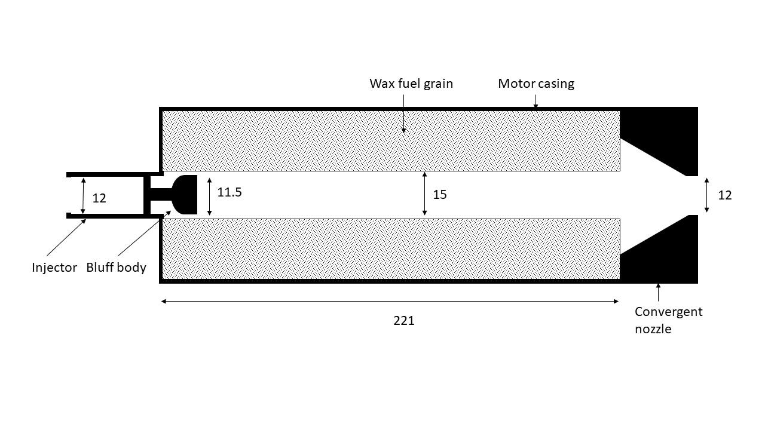

Figure 3: Schematic diagram of the hybrid rocket motor assembly (all dimensions are in mm).

**Test procedure**

1. Measure the mass of the fuel block and initial port diameter.
2. Assemble the hybrid rocket and connect the oxygen hose to the hybrid rocket.
3. Connect the pressure transducer to the chamber ports and then to the computer through a data acquisition system.
4. Supply oxygen to the settling chamber for a predetermined pressure through oxygen cylinders.
5. Connect the sequential timer and ignition battery as shown in Fig. 3. Set the operation time for ignition and oxidizer supply in series.
6. After the combustion of wax with oxygen, measure the fuel mass, pressure of settling and combustion chamber.
7. Repeat the steps from 1 to 6

**Tabular Column**

Composition of fuel grain : 30% of microcrystalline wax and 70% of paraffin wax

Density of fuel grain (*ρf*) : 890 kg∕m3

Length of fuel grain (*Lg*) : 221mm

Initial mass of fuel grain :

Final mass of fuel grain :

Burn time (*tb*) : 1sec

| Test No. | Mass of fuel burnt (*mf*) (grams) | Mass flow rate of oxidizer, (${\dot{m}}_{ox}$)  (in g/s) | $c_{the}^{*}$ (m/s)  from CEA | Combustion chamber pressure, (Pc) (bar) |
| --- | --- | --- | --- | --- |
| **1** | 27.7 | 26.13 | 1371.2 | 6.17 |
| **2** | 24.62 | 25.84 | 1409.4 | 5.62 |
| **3** | 23.03 | 25.73 | 1438.1 | 5.77 |
| **4** | 20.99 | 25.9 | 1529.3 | 5.53 |
| **5** | 19.26 | 25.76 | 1602.7 | 5.5 |

| Test No. | Mass of fuel burnt (*mf*) | Initial port diameter (*di*)  ( in mm ) | Final port diameter,(*df*)  ( in mm ) | Final port area (*Ap*)  ( in mm2 ) | *Gox*  ( in kg/m2.s) | Regression rate, $\dot{r}$ ( in mm/s ) | $η_{C^{*}}$ |
| --- | --- | --- | --- | --- | --- | --- | --- |
| **1** | **27.70** | **15.0000** | **20.1075** | **242.0079** | **107.972** | **2.5537** | **0.9454** |
| **2** | **24.62** | **20.1075** | **23.7420** | **377.5374** | **68.444** | **1.8173** | **0.8937** |
| **3** | **23.03** | **23.7420** | **26.6977** | **499.5456** | **51.507** | **1.4778** | **0.9306** |
| **4** | **20.99** | **26.6977** | **29.1314** | **611.9998** | **42.320** | **1.2169** | **0.8722** |
| **5** | **19.26** | **29.1314** | **31.1980** | **714.6426** | **36.046** | **1.0333** | **0.8621** |

**Calculations**

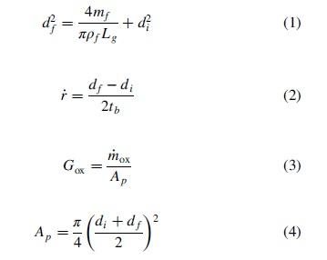

$η_{C^{*}}=\frac{{C^{*}}_{exp}}{{C^{*}}_{the}}$ (5)

${c^{*}}_{exp}=\frac{P_{c}A_{t}}{\dot{m}}$ (6)

**Results and Discussion**

Plot : Gox vs $\dot{r}$

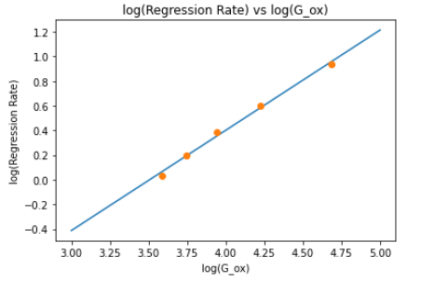

With the equation of the best fit linear curve being : 0.8137 x - 2.853

Thus, taking log, the relation $\dot{r}$ = a.(Gox)m

and comparing with the best linear fit, we get **m = 0.8137** and **a = 0.05767** in **SI units**

**Conclusions**

* log $\dot{r}$ vs log(Gox) is monotonically increasing
* **m = 0.8137** and **a = 0.05767** in **SI units**
* For a fixed amount of fuel and oxidizer, it has been reported that the fuel regression weakly depends on the pressure of the combustion chamber, longitudinal distance from the edge of the fuel, and port diameter of the fuel